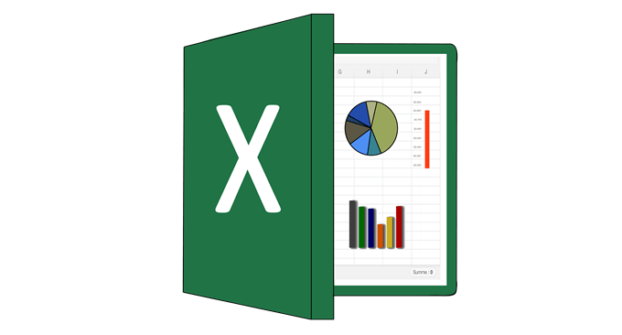

Microsoft Excel 2019

Last/Name:

Teacher:

Name:

1. What is Ms. Excel?
2. What is Range?
3. What is Basic Operator in Excel and Write the names in English?
4. Is it possible to prevent someone from copying the cell from your worksheet?
5. If yes how?
6. No
7. How many data Formats are available in Excel? name some of them.
8. How can you merge cells in Excel?
9. What is format pointer used for?
10. How would you clear all the formatting without removing the cell content?
11. What is the Difference between Count, Count A, count if and Count Blank in Excel Describe them clearly?

--------------------------------------------------------------------------------------------------------------

1. What is the function argument of COUNTA?
2. Vlue1, value2, value3…...255
3. Vlue1, value2, value 3…...128
4. Number1, number2, number3….255
5. Number 1, number2, number3…...128
6. Initial reals Ms. Excel For Window and Mac Os.
7. 1985,1978 b) 1987,1985 c)1958,1978 1978,1988
8. What is the Maximum number of column & rows in Excel Worksheet?
9. 1048576R, 16382C b)1048576R, 16374C c)1048576R, 16384C

c) None

1. Pivot table
2. Easily arrange and summarize complex data in a pivot table
3. Create a table to organize and analyze related data.
4. Draw text any where
5. Add common mathematical questions to your document, such as the area of a circle or the quadratic formula.
6. What is the syntax of Index?
7. =INDEX (array,row_index[column_number])
8. =INDEX (lookup_value, lookup_array[index_type])
9. =INDEX (lookup_value, table_array[index_type])
10. None
11. Substitute is belonging to?
12. Logical Function c) VLOOKUP function
13. Text Function d) sum if function
14. Proper is...?
15. Convert text string to all type upper case.
16. Covert a text String to First letter in each word to be upper case.
17. Remove all Space from text string
18. Covert a number from one measurement system to another
19. Cell References are Divided in to?
20. 3part b) 4part c) 6part d) None
21. Delimited is belong to?
22. subtotal b) substitute
23. c) Text to Column d) Data Validation.
24. From Which Ribbon we can change page Orientation to Landscape?
25. Home b) Page Layout c) Review d) Formula
26. Formula in Excel Start With?
27. % b) = c) + d) -
28. Which Function will be use to enter current time in a worksheet cell?
29. Today b) Time c) Now d) Current Time
30. Which key, when it pressed in the same time that word types capital?
31. Ctrl b) Shift c) Alt d) Tab
32. You Can Auto Fit the Width of Column By?
33. Double Clicking on the column on column header.
34. Double Click on the cell Pointer in Worksheet.
35. Double Click on Column Right Border on Column Header .
36. Double Click on the column left border of column header.
37. Border Can applies to?
38. Cells b) Paragraph c) Text d) All a,b,c
39. Portrait and Landscape are?
40. Page layout b) Page Orientation c) Page Size d) All above.
41. What are the shortcut keys for AutoSum?
42. Alt and S b) ALT and =
43. CTRL and S d) CTRL and =
44. What are the Keyboard shortcut keys to paste special?
45. ALT+ H+ V+ F b) ALT+ H +V+O
46. ALT+ H +V+P d) ALT+ H +V+S
47. Which of the following features cannot be found in the Data ribbon?
48. What-if Analysis
49. Pivot Table
50. Data Validation
51. Text to Column.
52. Which tab of the ribbon should you go to for removing Gridlines on a worksheet?
53. Page Layout b) View c) Review d) Developer
54. What is the Keyboard Shortcut key to lock cell reference in a formula?
55. Ctrl b) Alt c) F2 d) F4

1. What is the syntax of VLOOKUP Function?
2. =VLOOKUP (lookup_value, table_array, row _index_number[range_lookup]
3. =VLOOKUP (lookup_value, table_array, col _index_number[range_lookup]
4. =VLOOKUP (lookup_value, lookup_victor, result_victor[range_lookup]
5. =VLOOKUP (lookup_value, row_number[column_number][range_lookup]
6. What is the Flash Fill?
7. Turn on filtering from the selected cell
8. Find a value quickly by sorting your data
9. Summarize Data From separate range
10. Automatically fill in values enter a couple of examples you want as output and keep the active cell in the column you want filled in.
11. What is the syntax of SUMIFS function?
12. =SUMIFS (Range, criteria)
13. =SUMIFS (Criteria_range1, criteria1…)
14. =SUMIFS (Range, Criteria, [sum_range])
15. =SUMIFS (sum_range, Criteria_range1, criteria1)
16. Which on is the last column in excel?
17. XDF b) FDX c) XFD d) XLS
18. What time you can see this #######error.
19. Text does not recognize
20. Enter a wrong formula
21. The number is divided by Zero
22. The size of column is not enough.